

SCHOOL

FEE SCHEDULE

It’s beyond Classroom, It’s

lifelong knowledge and skills

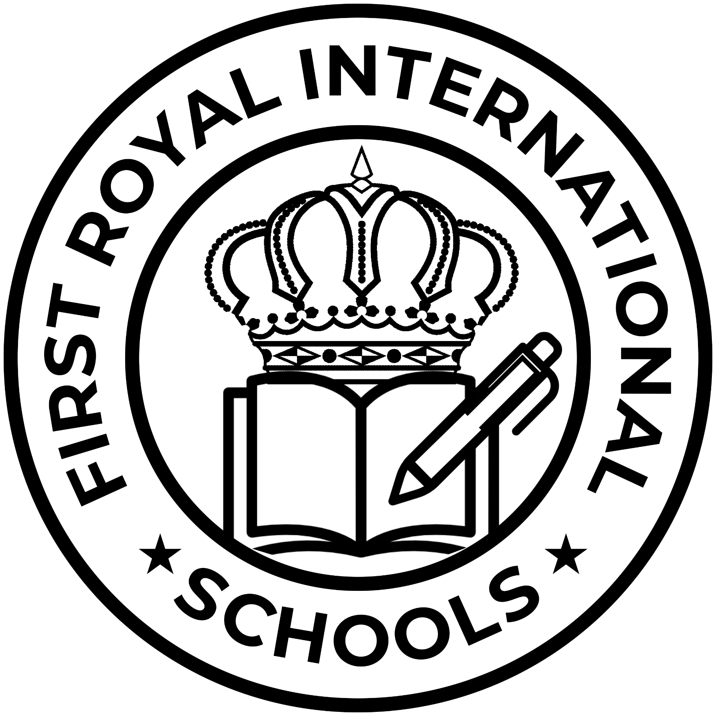

DESIGNED BY: HOK COMPUTERS

# FIRST ROYAL INTERNATIONAL SCHOOLS

1.Parents must respect the laws and regulations of the institution and other routine guidelines that may be issued from time to time by competent authorities.

2.Parents are to be member of the PTA and be fully involved in the deliberations, activities and functions.

3.Parents must ensure that pupils/students regularly attend the school promptly and ensure adequate provisions for the timely evacuation from school as well as nutrition and health of their wards.

4.Parents must not engage in any altercation, arguments or other inappropriate confrontational behavior with staff.

SCHOOL FEE

SCHEDULE

5.Parents are to courteously demand explanations concerning their wards’/children condition or situation from the class teacher and promptly leave complaint with Head Teachers if not satisfied by class Teacher’s explanations.

6.Parents must not be engaged in any physical or verbal tango and fisticuffs with staff.

7.Parents are expected to be seen, to be alert and adequately involve in the educational progress of their wards.



# FIRST ROYAL INTERNATIONAL SCHOOLS



Follow Us On

Kudenda

and Kakuri Branches, Kaduna, Nigeria



# Equipping the Total Child

